**Buckhannon & Tygart Valley River Water Trail**

Draft Designation Request

Submitted to WV Department of Transportation

Submitted by the Buckhannon River Watershed Association and Save the Tygart Watershed Association

3/25/2024

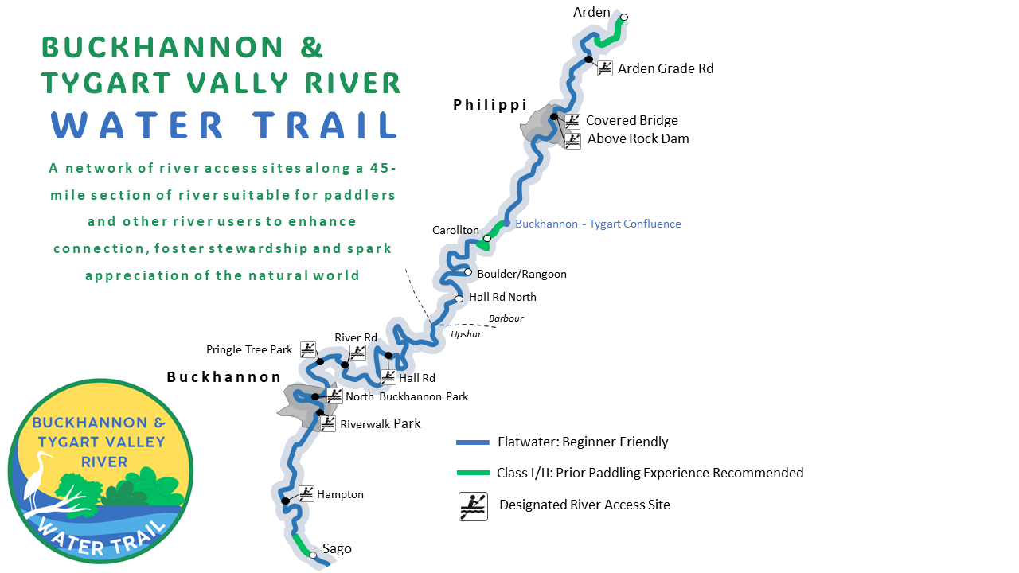

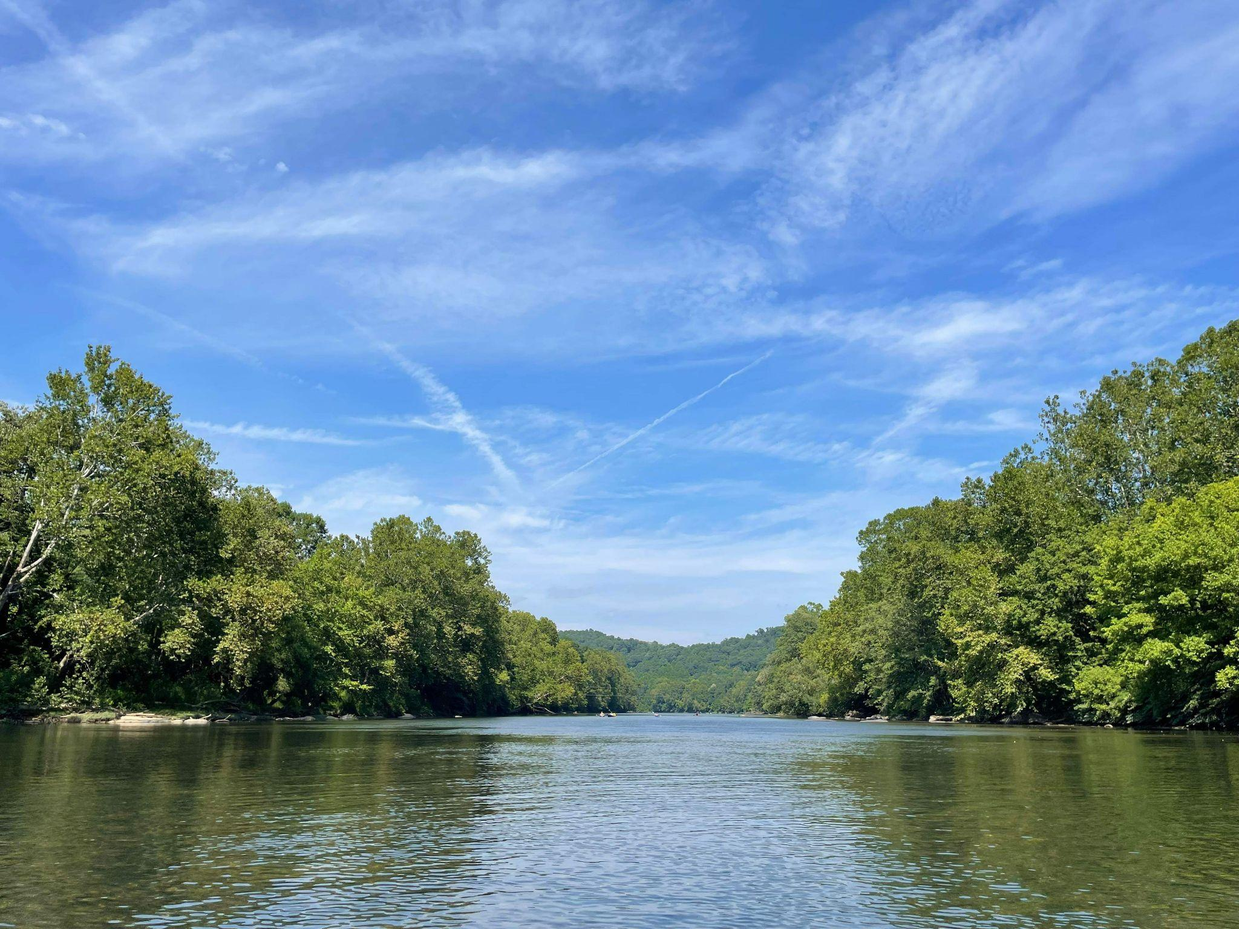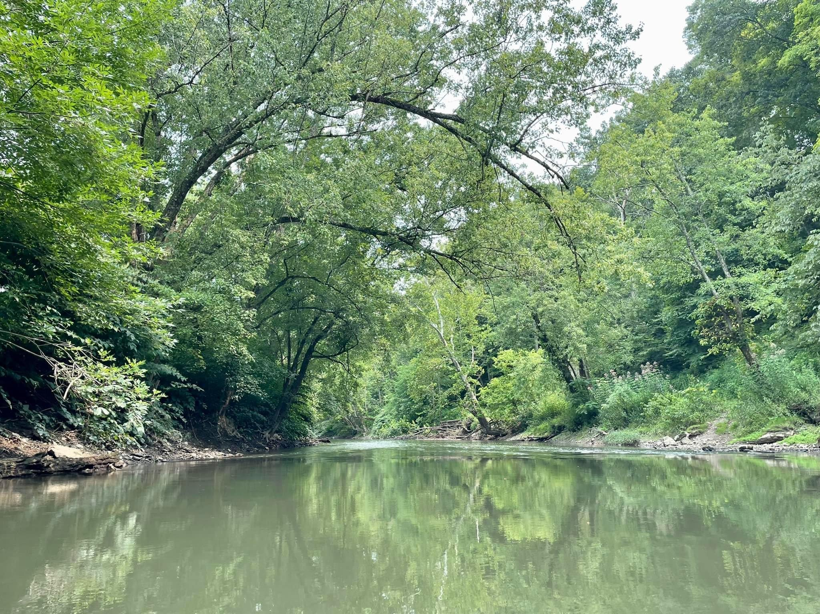

Buckhannon River Tygart Valley River

**Table of Contents**

**Vision 3**

**What is a Water Trail? 3**

**Suitable Section for Water Trail 3**

**State Water Trail Designation 3**

**Primary Co-Sponsors 4**

**Water Trail Working Group 5**

**River Description 5**

Section #1: Sago to Buckhannon Riverwalk Park (7.5 miles) 5

Section #2: North Buckhannon Park to Boulder (21.5 miles) 6

Section #3: Boulder/Rangoon to Philippi (11.5 miles) 7

Section #4: Philippi Covered Bridge to Arden (7 miles) 7

**Flow Conditions 8**

**River Hazards 8**

**River Access 9**

River Access Site List 9

Maintenance 10

Trail Map, Informational Material, and Signage 10

**Recreational, Scenic, Historical, and Educational Opportunities 10**

Flora and Fauna 10

Human History 11

Historical Sites and Points of Interest 11

**The Planning Process: Public Outreach and Local Government 14**

Public Information & Printed Materials 14

Working Group Meetings 14

Local Government 15

Public Meetings 15

**Appendices 16**

Appendix A: River Access Site Inventory Checklist 16

Appendix B: River Access Site Summary 17

Appendix C: Signed Resolutions 18

Appendix D: Water Trail Presentation Slides 20

# 

# Vision

Our vision is to establish a network of river access sites along a 45-mile section of river suitable for paddlers and other river users to enhance connection, foster stewardship and spark appreciation of the natural world.

Our goal of this project is to develop a Water Trail on suitable sections of Buckhannon and Tygart Valley Rivers and to obtain official designation as a West Virginia State Water Trail. We hope the establishment of a Water Trail can be a way to enhance recreational opportunities and general appreciation of the river, leading to increased support of conservation efforts.

# What is a Water Trail?

A Water Trail is a sponsored and maintained recreational route along a waterway that is promoted by local entities with publicly accessible access points. The Water Trail is a navigable route for canoes, kayaks, stand up paddle boards, and other non-motorized recreational boaters. Along the way, there is a network of publicly accessible areas where river users can park vehicles and access the river. River access sites are spaced apart so that the section of river may be paddled in a few hours or a full day (3 - 7 miles apart). The Water Trail provides a unique perspective to experience the landscape from the river’s view, while enjoying scenic, educational, historical, and cultural points of interest. A Water Trail promotes Leave No Trace principle, respect for private landowners, proper river safety, and fishing and boating regulations.

# Suitable Section for Water Trail

The proposed Buckhannon and Tygart Valley River Water Trail is 45 miles originating near the community of Sago in Upshur County and ending near the Arden community in Barbour County. The trail is mostly flatwater with occasional riffles, offering excellent beginner and family friendly routes. The proposed Water Trail flows through peaceful landscapes, quiet meanders, and mature forested landscapes, as well as communities rich in history, including two historic covered bridges. Wildlife is plentiful along the entire waterway, with herons, beavers, and bald eagles among the highlights. There are three short sections of Class I/II water from Carrollton to Tygart Junction for more experienced paddlers to explore.

# State Water Trail Designation

The West Virginia Department of Transportation Recreational Trail Advisory Board oversees the application and approval process to become a designated Water Trail. Once a Water Trail achieves official designation, funding opportunities through the Department of Transportation/Division of Highways, via the FHWA-funded Recreational Trails grants become available.

List of current designated WV Water Trails from the WVDNR Fishing Regulations Summary (2024) page 17:

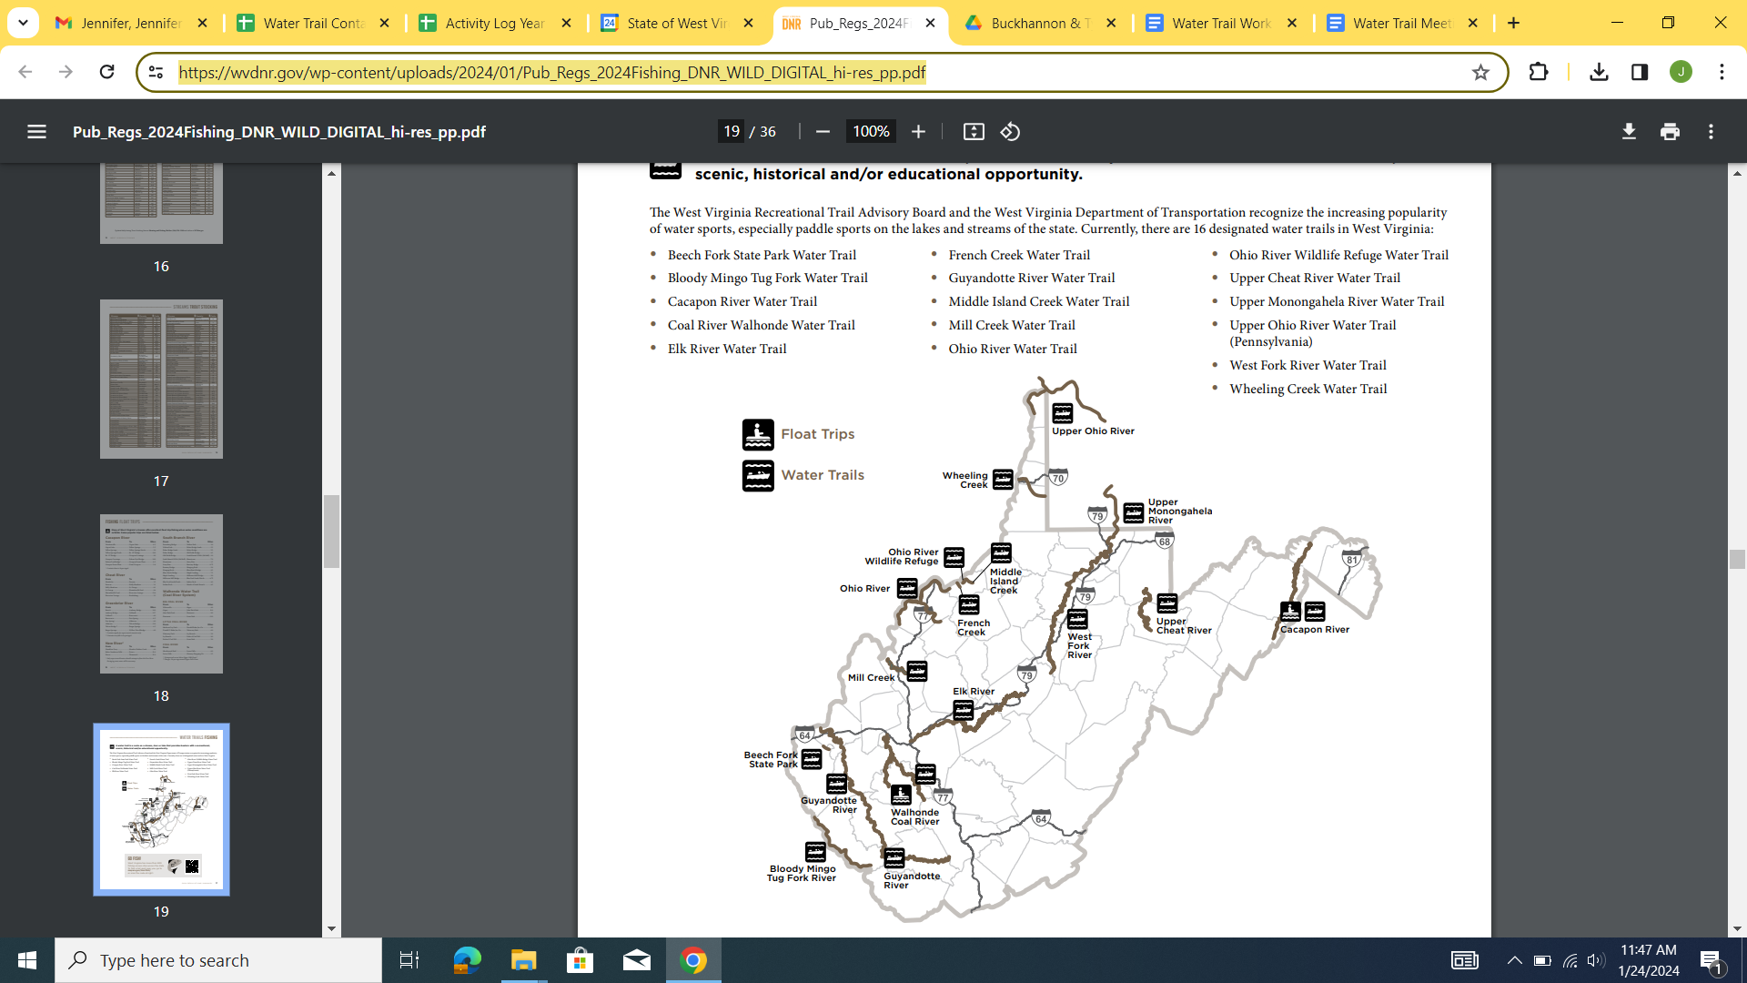

# Primary Co-Sponsors

The Buckhannon River Watershed Association (BRWA) and Save the Tygart Watershed Association (STTWA) are the primary co-sponsors of the Water Trail. Both groups are grassroots 501(c)(3) organizations assembled by concerned citizens to monitor and improve water quality of the rivers.

All applications for grant funding for the trail or its amenities submitted to the WV

Recreational Trail Advisory Board will be approved by the primary co-sponsors. BRWA, STTWA, and the Buckhannon & Tygart Valley River Water Trail Working Group assumes responsibility for coordinating maintenance and upkeep of public access points, trailside amenities, signage, maps, guides, or website developed with grant funds awarded by WV Recreational Trail Advisory Board, or the WV Recreational Trails Program.

# Water Trail Working Group

The Buckhannon & Tygart Valley River Water Trail Working Group includes representatives from partnering organizations and community stakeholders to oversee the planning, development, maintenance, and management of the Water Trail. The meetings are open to the public and new members are encouraged to attend and participate.

## Working Group Members:

**Chrissy Sandy**, BRWA board member

**Lisa Gum**, BRWA board member  
 **Kelley Flaherty**, Save the Tygart Executive Director

**Jeremiah McCourt**, Upshur County Parks & Recreation Director

**Brandon Tenney**, Upshur County Development Authority

**Lacy Ramsey**, Upshur County CVB

**Jeremy Drennan**, Philippi City Manager

**Shannon Fry**, Barbour County Commission Representatives

**Jessica Bryzek**, AmeriCorps VISTA DEP/Conservation Legacy, BRWA

# River Description

Both the Buckhannon and Tygart Valley Rivers originate in the elevated Allegheny mountains of central West Virginia. Both rivers flow through the Forested Hills and Mountain ecoregion. Characterized by rugged topography and rich woodlands, numerous small tributaries carve the crumbled landscapes and feed the mainstem rivers that are guarded by steep slopes and exposed cliff faces. Both rivers flow in a general northern direction. The Buckhannon River is 45 miles long and joins the Tygart Valley River south of Philippi at the Tygart Junction. The Tygart Valley River continues its journey until it joins the West Fork River in Fairmont to form the Monongahela River.

## Section #1: Sago to Buckhannon Riverwalk Park (7.5 miles)

The proposed start of the Water Trail is near Sago, WV. Currently, there is an unofficial access site at this location with a small pull off area and steps down to the river. In the future, this access site will need significant improvements. Just downstream, the river channel splits around a small island. The river passes under the one-lane bridge in Sago and continues through a half mile Class I riffle section, after which the current slows significantly. The river meanders slowly through a remote and scenic gorge for 2 miles. French Creek, a major tributary, enters on river left. Approximately ¼ mile later, the river passes beneath the Ivanhoe Road bridge and Hampton Public Access Site appears on river left, 3.5 miles from the Sago Put-In.

After Hampton, the river deepens, and the current slows significantly as the Buckhannon Pool forms, a deep slow channel formed by a low-head dam in downtown Buckhannon, approximately 5 miles away. For 2.5 miles, the river placidly flows through mature forests with some residential houses visible from the riverway. Passing under the Tallmansville Road bridge, the river continues through residential scenery as paddlers enter Buckhannon city limits. The Riverwalk Park Access Site appears on river left, 4.5 miles from Hampton.

We recommend all paddlers exit the river at Riverwalk Park. There is a low head dam approximately ½ mile downstream from the Riverwalk Park boat ramp, and there is no easy portage around the dam. Approximately 800 ft after the first low head dam, the river splits into two channels. One channel cuts due north and passes over a second low head, continuing ⅓ mile to North Buckhannon Park. The other channel weaves through “the loop”, a large meander with low water and minimal flow as it snakes through a residential area for 1.4 miles before rejoining the other channel.

## Section #2: North Buckhannon Park to Boulder (21.5 miles)

The City of Buckhannon currently has plans to improve the Public Access Site at North Buckhannon Park from a grass carry down access to a concrete ramp. Downstream of North Buckhannon Park the river flows through beautiful rural scenery, alternating between mature forest and pasture. This section offers excellent scenic and wildlife viewing opportunities as paddlers leave the city of Buckhannon. The river passes under the U.S. Route 33 bridge and under the Post Mill Road bridge. In this section, the river is mostly slow and shallow, with some deep pools and very short segments of flowing rifles. Pringle Tree Park appears on river left after 3.75 miles from North Buckhannon Park.

The river lazily flows past Pringle Tree Park and passes under Post Mill Road for a second time, along with two other small railroad bridges. The River Road Public Access site appears on river right 1.25 miles after Pringle Tree Park. Downstream, the river continues through long, deep pools interspersed with short rifles for 4 miles to Hall Road South Access Site. In this section, the river regains its natural flow characteristics as large in-stream boulders become visible.

After the Hall Road South Public Access Site, the river meanders for 7 miles to the next potential access site, Hall Road North. This section is the longest mileage between access sites and is also the most remote section of the proposed Water Trail. The river flows through numerous meanders and passes through an especially scenic forest gorge. Sand Run, a tributary, enters on river right, and then the river passes through the Wentz Ford community. After passing through this small residential area, the river gradient increases slightly as the slow pools are replaced with Class I riffles and rock gardens before passing under Hall Road.

After Hall Road, the river resumes its leisurely character for 2.5 miles to Audra Park Road Bridge. Just upstream of the bridge, a small Class I riffle and rock garden segment appear. The river passes beneath Audra Park Rd at the community of Boulder/Rangoon. There is a carry down access site at this location on river right.

## Section #3: Boulder/Rangoon to Philippi (11.5 miles)

Shortly downstream of the Boulder/Rangoon bridge, the river flows over a small rock dam and continues through flatwater surrounded by forested and rural scenery. Eventually, the river flows through rural residential communities along Buckhannon River Road. Near the end of the residential section, the river gradient increases and the river flows through class I and II rapids. The river flows under the Carrollton Covered Bridge. For ¾ mile there are continuous Class I and Class II rapids until the Buckhannon river confluence with Tygart river.

Downstream of the confluence, the Tygart Valley River flows 5 miles of primarily flatwater through a scenic and remote gorge. As the river flows through the City of Philippi, there are numerous amenities and points of interest. There is a concrete boat ramp on river left just upstream of the rock dam. Paddlers can exit the river via a concrete boat ramp on the river left upstream of the dam, or continue towards the dam and portage on the river right through the Vietnam Veterans Park. Just under the Covered Bridge is an established Public Access Site on the river left with a concrete boat ramp.

## Section #4: Philippi Covered Bridge to Arden (7 miles)

Downstream of the Philippi Covered Bridge, the Tygart Valley River continues its journey through a scenic and beautiful flatwater section. The river is mostly slow and placid, alternating both deep and shallow sections with short segments of riffles. A small Public Access Site along Arden Grade Road appears on river right, 3.6 miles downstream of Philippi. Arden Grade Rd, a small gravel road, parallels the river for most of its course from Philippi to Arden. Approximately 1 mile upstream of Arden, the river begins to increase gradient and Class I and II rapids appear. These rapids can be avoided by taking out at the Arden Grade Road access site, and we recommend only experienced paddlers continue to the Arden bridge take out. Downstream of the bridge, the Tygart begins its tumultuous journey through Class III-V whitewater and eventually feeds into Tygart Lake, a man-made reservoir near Grafton, WV.

# Flow Conditions

There is one USGS Stream Gauges along the Water Trail, located on the Buckhannon River at Hall Rd (GPS: 39.051252, -80.114512). 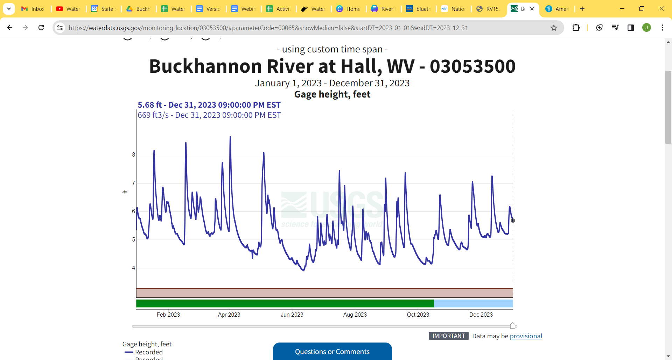

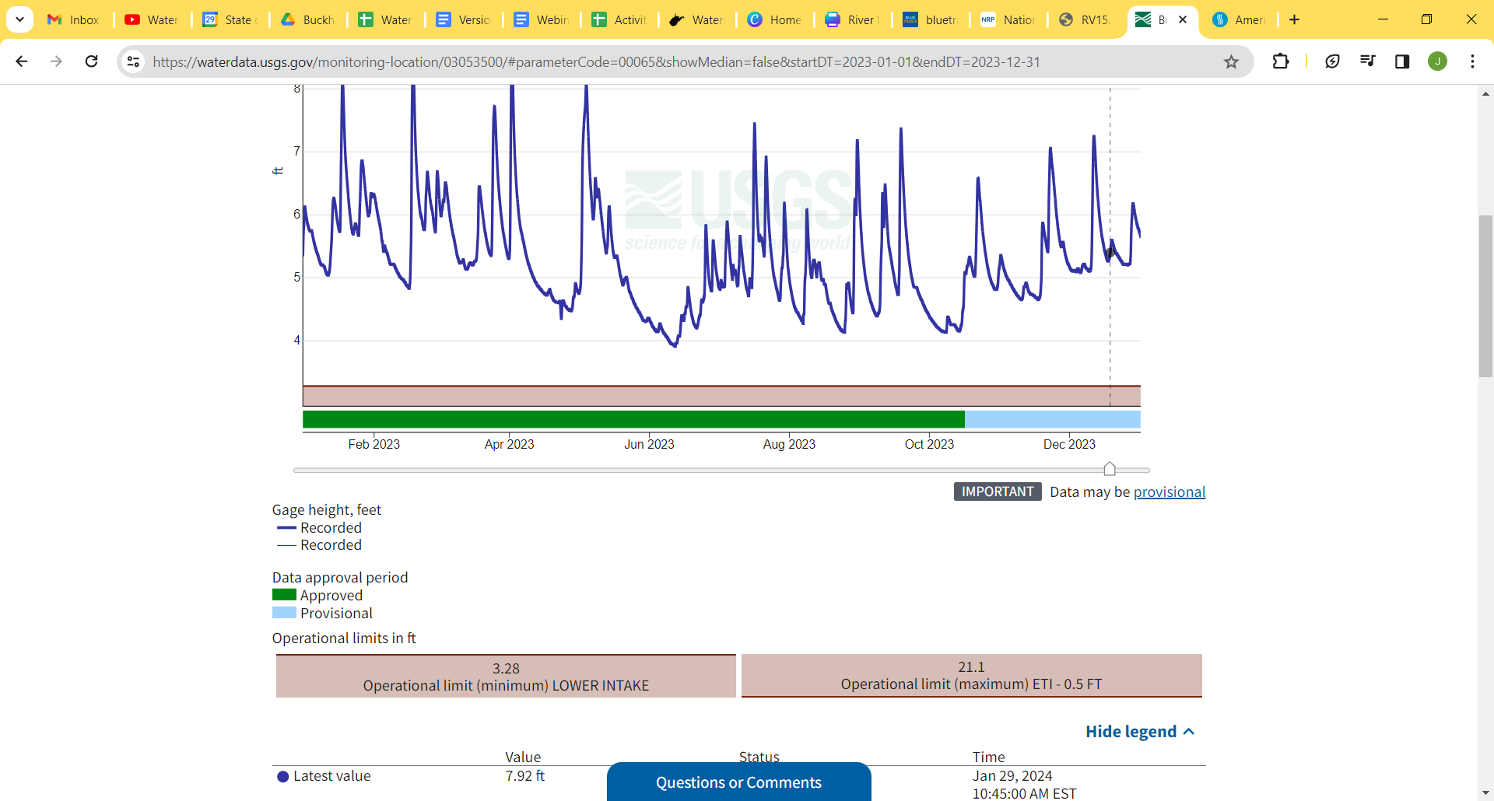

# River Hazards

For most of its course, the proposed Water Trail is slow and placid, offering excellent beginner friendly paddle opportunities. River hazards along the proposed Water Trail include:

| **Water Trail Mile** | **Hazard** |
| --- | --- |
| 0.8 | ¾ mile of Class I/II riffles downstream of the Sago bridge |
| 8.0 | Two low-head dams on the Buckhannon River in the City of Buckhannon located between the Riverwalk Park and North Buckhannon Park. We recommend all paddlers take out at Riverwalk Park, then drive to North Buckhannon Park to continue their paddle. |
| 30.8 | There are 2 miles of class I/II rapids starting 0.75 miles upstream of Carrollton and continuing to Tygart Junction. |
| 37.8 | Rock Dam on the Tygart River upstream of Philippi. There are two established Access Sites upstream and downstream of the dam, which make it easy for paddlers to avoid the dam. It is also possible to portage the dam on river right. |
| 43.5 | 1 mile of Class I/II rapids starting 1.7 miles downstream of the Arden Grade Rd Access site and continuing to the Arden Bridge. |

# River Access

Members of the Working Group have evaluated access sites using the River Access Site Inventory Checklist (Appendix A). Brief results of the inventory are presently below. A full description of the inventory can be found in the River Access Site Summary (Appendix B).

## River Access Site List

| **Site** | **Latitude** | **Longitude** | **Trail Mile** | **Miles to Next Put In** | **Property Owner** | **Access Type** |
| --- | --- | --- | --- | --- | --- | --- |
| **Sago** | 38.906738 | -80.218875 | 0 | 3.5 | Private | Unofficial access |
| **Hampton** | 38.938918 | -80.238914 | 3.5 | 4.5 | Upshur County Commission | Concrete Ramp |
| **Riverwalk** | 38.991399 | -80.212464 | 7.5 | 1.4 (Dam portage required) | City of Buckhannon | Concrete Ramp |
| **North Buckhannon Park** | 38.996188 | -80.217357 | 8.5 | 3.75 | City of Buckhannon | Carry Down |
| **Pringle Tree Park** | 39.018705 | -80.207663 | 12.25 | 1.25 | Upshur County Commission | Carry Down |
| **River Rd** | 39.010624 | -80.193247 | 13.5 | 4 | City of Buckhannon | Concrete Ramp |
| **Hall Rd South** | 39.020832 | -80.163518 | 17.5 | 7 | Upshur County Commission | Concrete Ramp |
| **Hall Rd North** | 39.053581 | -80.111064 | 24.5 | 2.5 | Private Landowner | Unofficial Access |
| **Boulder/ Rangoon** | 39.068793 | -80.103374 | 27 | 4.5 | Private Landowner | Unofficial Access |
| **Carrollton** | 39.089922 | -80.086251 | 31.5 | 6 | Private Landowner | Unofficial Access |
| **Phillippi Upstream** | 39.149779 | -80.04008 | 37.5 | 0.3 | City of Philippi | Concrete Ramp |
| **Phillippi Covered Bridge** | 39.152849 | -80.04353 | 37.8 | 3.6 | WV Department of Highways | Concrete Ramp |
| **Arden Grade Rd** | 39.189778 | -80.016254 | 41.5 | 3.25 | City of Philippi | Concrete Ramp |
| **Arden Bridge** | 39.210349 | -79.994786 | 44.65 | - |  | Unofficial Access |

## Maintenance

The proposed Water Trail travels through both Upshur and Barbour counties. The Upshur County Parks & Recreation Department and the City of Buckhannon Parks Department maintain the public access sites in Upshur County. The City of Philippi maintains the 3 existing access sites in Barbour County.

## Trail Map, Informational Material, and Signage

Public information, in both printed and web-based formats, will be actively distributed after designation. The Working Group and partner organizations will oversee the development and maintenance of public information. A Water Trail map (Figure 1) will be available free of charge on printed paper at river access sites and other public locations such as the Upshur County CVB and Philippi Visitor’s Center. Appropriate signage will be installed at all river access sites including: Water Trail map, accurate mileage between river access sites, section difficulty, and potential river hazards. In addition, a website will be developed and maintained promoting the Water Trail and include a paddle planning guide. More detailed information and preliminary documents are presented in the Public Information & Printed Materials section.

# Recreational, Scenic, Historical, and Educational Opportunities

The proposed Buckhannon & Tygart River Water Trail tells an interconnected story of the natural landscape and its flora/fauna, as well as human culture, heritage, and history.

## Flora and Fauna

Mature forested communities dominate the riparian area along the riverway. Large maples, black cherry, ash, elms, and sycamore trees stand tall along the river banks. Numerous types of wildlife and fish call the river and the surrounding riparian area home. Birds utilize the river as a corridor, and the tall mature trees along the river are used as habitat. Hawks, king fishers, blue and green herons, wood ducks, mallards, and bald eagles are commonly seen while paddling. Mammals such as chipmunk, squirrel, river otter, groundhog, muskrat, and foxes can also be seen scurrying along the river banks or swimming in the water. In the warmer weather, turtles, frogs, and salamanders bask in the sun, and butterflies, dragonflies, and damselflies can be heard buzzing around. Spring ephemerals and summer wildflowers are especially plentiful alongside the river. Fishing opportunities are also excellent. The Buckhannon River is well-known as one of the best locations for musky fishing in the state. The WVDNR stocks brook, brown, and rainbow trout twice a year on a 20 mile segment of the Buckhannon River. Other common fish include smallmouth and largemouth bass, and bluegill.

## Human History

The region is rich in social, cultural, and historical heritage. Many indigenous tribes used this area for hunting and gathering, as well as traveling between other lands. Calicuas, Massawomek, Shawandasse, S’atsoyaha, and Osage are among the many indigenous tribes that are recognized to have lived in this area. Buckongahelas of the Lenape Delaware tribe traveled from what is now considered Delaware eastward, and lived for a time in the area that is now Buckhannon in Upshur County, WV.

Samuel and John Pringle were the first European settlers of Upshur County, arriving in 1762 and living along the Buckhannon River. The brothers even hid in a giant hollow Sycamore for two years evading the British Army. The Monongahela River and its upper tributaries were the main highways for European settlement in the coming decades. After more settlers arrived, several small communities were formed along the Buckhannon River. The land was cleared for farming, and the timber was used to build rail lines. As communities grew, lumbering became the primary industry and several grist mills were constructed. Today, ghost towns are common along the Buckhannon River where mills once stood including Beans Mill and Ours Mills. In the early stages of the Civil War during the summer of 1861, many troops were stationed in the Buckhannon/Philippi region. The Battle of Philippi occurred on June 3, 1861 and is recognized as the first organized land battle of the Civil War. At the turn of the twentieth century, the coal industry began to grow leading to many large deep mines and strip mines. The oil and gas industry began to grow a few decades later.

The rich human history in the region has negatively impacted the environment and natural resources in the watershed. For over two decades, concerned citizens of Save the Tygart Watershed Association and Buckhannon River Watershed Association have focused grassroots efforts to improve water quality. Many conservation threats still remain. Restoration and protection of the riverway is an on-going effort.

## Historical Sites and Points of Interest

Along the Water Trail, historical sites and points of interest include:

| **Sago Mine** | The proposed Water Trail starts near Sago Mine, the site of one of the worst mining disasters in WV history. In 2006, thirteen miners were trapped in the mine and only one made it out alive. The Sago Mine memorial stands near the site of the bridge over Buckhannon River at Sago. This disaster is an important piece of coal mining history in WV. |
| --- | --- |
| **Buckhannon Pool** | A 6.5 mile designated muskie catch and release section on the Buckhannon River. This site flows under Hampton bridge. |
| **Riverwalk Park** | Public park with boat access, basketball courts, green spaces, dog park, restrooms, picnic table, and walking trail. Home to the annual Buckhannon RiverFest held each August and the Jack Barker Memorial Canoe Race each May (in its 48th year running). |
| **River Walk Trail** | A 3-mile paved walking trail with sections following the Buckhannon River and provides access to the nature trail with interpretive signage.The West Virginia Wesleyan College campus lies next to the river access as well. |
| **City of Buckhannon** | Buckhannon is nestled in central West Virginia in the foothills of the Allegheny Mountains. The city offers numerous attractions, amenities, and hosts many fairs and festivals throughout the year. |
| **North Buckhannon Park** | Public park with ADA accessible playground equipment, pavilion, athletic fields, restrooms, river access site and access to the walking trail. |
| **Pringle Tree Park** | Pringle Tree Park hosts a 300-year old Sycamore tree. Standing over 100 feet tall with gnarled branches, peeling bark, and a hollowed trunk, this Sycamore tree showcases the breathtaking beauty of the tallest native West Virginia tree. |
| **Carrollton Covered Bridge** | The Carrollton Covered Bridge is listed on the National Register of Historic Places. The bridge is 16 feet wide and 140.75 feet long and was built in 1856 by Emmett and Daniel O’Brien utilizing the Burr Arch design, consisting of two long arches resting on abutments at each end boarded by kingpost truss. The covered bridge was renovated by Hoke Brothers Contracting Union in 2002. |
| **Tygart Junction** | At the confluence of the Tygart and Buckhannon rivers, lies a major railroad junction and an abandoned rail-road town. |
| **Blue & Grey Park** | A veterans memorial park offering public parking, river access and views of the covered bridge. |
| **City of Philippi** | Historic town (1844) nestled along the banks of the Tygart Valley River offering modern conveniences. The first-land battle of the Civil War occurred here and sections of the town have been awarded historic district status. Home to the annual Blue & Grey festival and LurchFest celebration. |
| **Philippi Trail System** | An 8 mile trail system parallels the Tygart Valley River and offers diverse trails ranging from flat & fast to rocky & technical suitable for mountain biking. |
| **Philippi Covered Bridge** | The Philippi covered bridge was one of the oldest covered bridges in the state, but unfortunately the structure burned in 1989 and reconstructed in 1991. The original structure was a double-barreled 286-foot long truss and was completed in 1852. |

In the vicinity of the Water Trail, historical sites and points of interests include:

| **WV State Wildlife Center** | Located 15 minutes from the start of the Water Trail the Wildlife Center is located in French Creek and includes a zoological park operated by the WVDNR and includes educational displays, wildlife exhibits, and walking trails. |
| --- | --- |
| **Indian Camp/Chimney Rock** | A notable natural feature in the watershed. |
|  |  |
| **Pickens, West Virginia** | Located in the remote forests of the upper Buckhannon River watershed, this historical mining and lumbering town offers unique museums and is home to the annual Maple Syrup Festival. |
| **Helvetia, West Virginia** | This isolated community was settled in 1869 by Swiss and German settlers. The community offers traditional dance, music, food, and festivals including Fasnacht, Follow Your Bliss Music Festival, and monthly square dances. |
| **Upshur County Recreational Park** | A public park with picnic tables, a pavilion, and a 9-mile trail system suitable for mountain biking and hiking. |
| **Audra State Park** | Located just 15 minutes from Boulder, Audra State Park offers beautiful hiking trails including the Alum Cave rock overhang, a playground, picnic areas, beach, and overnight camping. |
| **Adaland Mansion** | Built in 1870 and located in Philippi, this historic brick home is listed on the National Register of Historic Places |
| **Barbour County Fairgrounds** | Located 10 minutes outside of Philippi, the Barbour County Fairgrounds is a public park with walking trails, basketball and tennis courts, and facilities for fairs and live entertainment. |
| **Tygart Valley River Whitewater** | Downstream of the Water Trail, the Tygart Valley River passes through a 6.7 mile segment of Class III-V whitewater. This section is for advanced paddlers only. Arden Grade Road follows the river offering scenic views of the rapids and waterfalls. |
| **Pleasant Valley Wildlife Management Area** | Located 10 minutes from Arden, the 3,000 acres WMA is managed by the WVDNR and offers excellent wildlife viewing opportunities, overnight camping, and access to Tygart Lake. |
| **Tygart Lake State Park** | Located near Grafton, Tygart Lake State Parks offers numerous recreational opportunities and overnight lodging options including camping, cabins, and a lodge. |

# 

# 

# 

# The Planning Process: Public Outreach and Local Government

## Public Information & Printed Materials

One of the first actions for the Working Group was to develop an official Water Trail logo (Figure 2). The second task is to develop preliminary drafts of Public Information including a Water Trail map and brochure. The third task is to design a website with additional information including a paddle trip planning guide.

## Working Group Meetings

Outreach to local organizations and individuals were conducted before the formation of the Working Group to gauge preliminary interest and collect feedback from potential partners. After preliminary outreach, a Working Group was formed to continue to oversee the designation process. A description of the meetings are described below.

| **February** | Finalize Primary Sponsors, brainstorm Water Trail vision statement and logo, discuss plan of action for designation |
| --- | --- |
| **March** | Finalize the Draft Request and plan for public comments/meeting |

## Local Government

Formal outreach to local government officials (Barbour and Upshur County Commissions) were conducted to present an overview of the Water Trail and included three main asks: 1) to adopt a resolution in support of the Water Trail, 2) designate a small pool of preliminary funds to be used as a start-up budget, and 3) to share enthusiasm for the Water Trail project. BRWA presented to the Upshur County Commission on February 29, 2024. Save the Tygart WA present to the Barbour County Commission on March 4, 2024. Both counties adopted the resolution to support the Water Trail (Appendix C).

## Public Meetings

The Working Group will host two public meetings, one in Buckhannon/Upshur County and one in Philippi/Barbour County, to encourage public participation and to provide opportunities for private citizens and community members to offer feedback. The public meetings will include information networking/mingling, presentation on the Water Trail and Access Sites (Appendix D), and time for question and answers. The following includes the Working Group’s plan for public outreach.

**Planned Agenda for Public Meetings**

| 6:00 PM | Doors open: sign-in sheet, welcome folks, distribute survey forms, comment cards, and informal mingling |
| --- | --- |
| 6:30 - 6:45 PM | Overview Presentation #1 followed by question and answers and informal mingling |
| 7:30 - 7:45 PM | Overview Presentation #2 followed by question and answers and informal mingling |
| 8:00 PM | Closing & Thank You’s |

We will insert a summary of each public meeting and comments received here.

# 

# Appendices

## Appendix A: River Access Site Inventory Checklist

| Site Name: |  |
| --- | --- |
| River Mile: |  |
| Lat/Long: |  |
| Property Owner: |  |
| Access Type: | Concrete ramp, carry down, or unofficial access |
| Restrooms: | Yes/No |
| Road Condition to Access Site: | Good, Fair, Poor - describe |
| Public Access Sign- From Road: | Is there a public access sign visible from the road? |
| Public Access Sign- From River: | Is there a public access sign visible from the river? |
| Trash Receptacle: | Yes/No |
| Picnic Table: | Yes/No |
| Informational Signage: | Yes/No |
| Describe Needed Improvements: |  |

## 

## 

## 

## 

## 

## Appendix B: River Access Site Summary

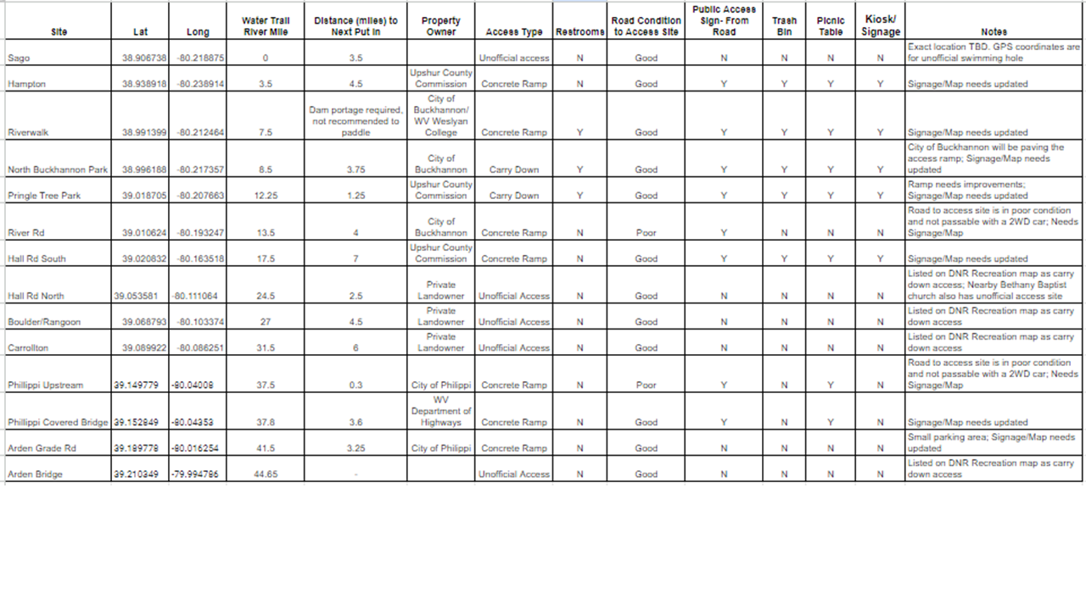

## Appendix C: Signed Resolutions

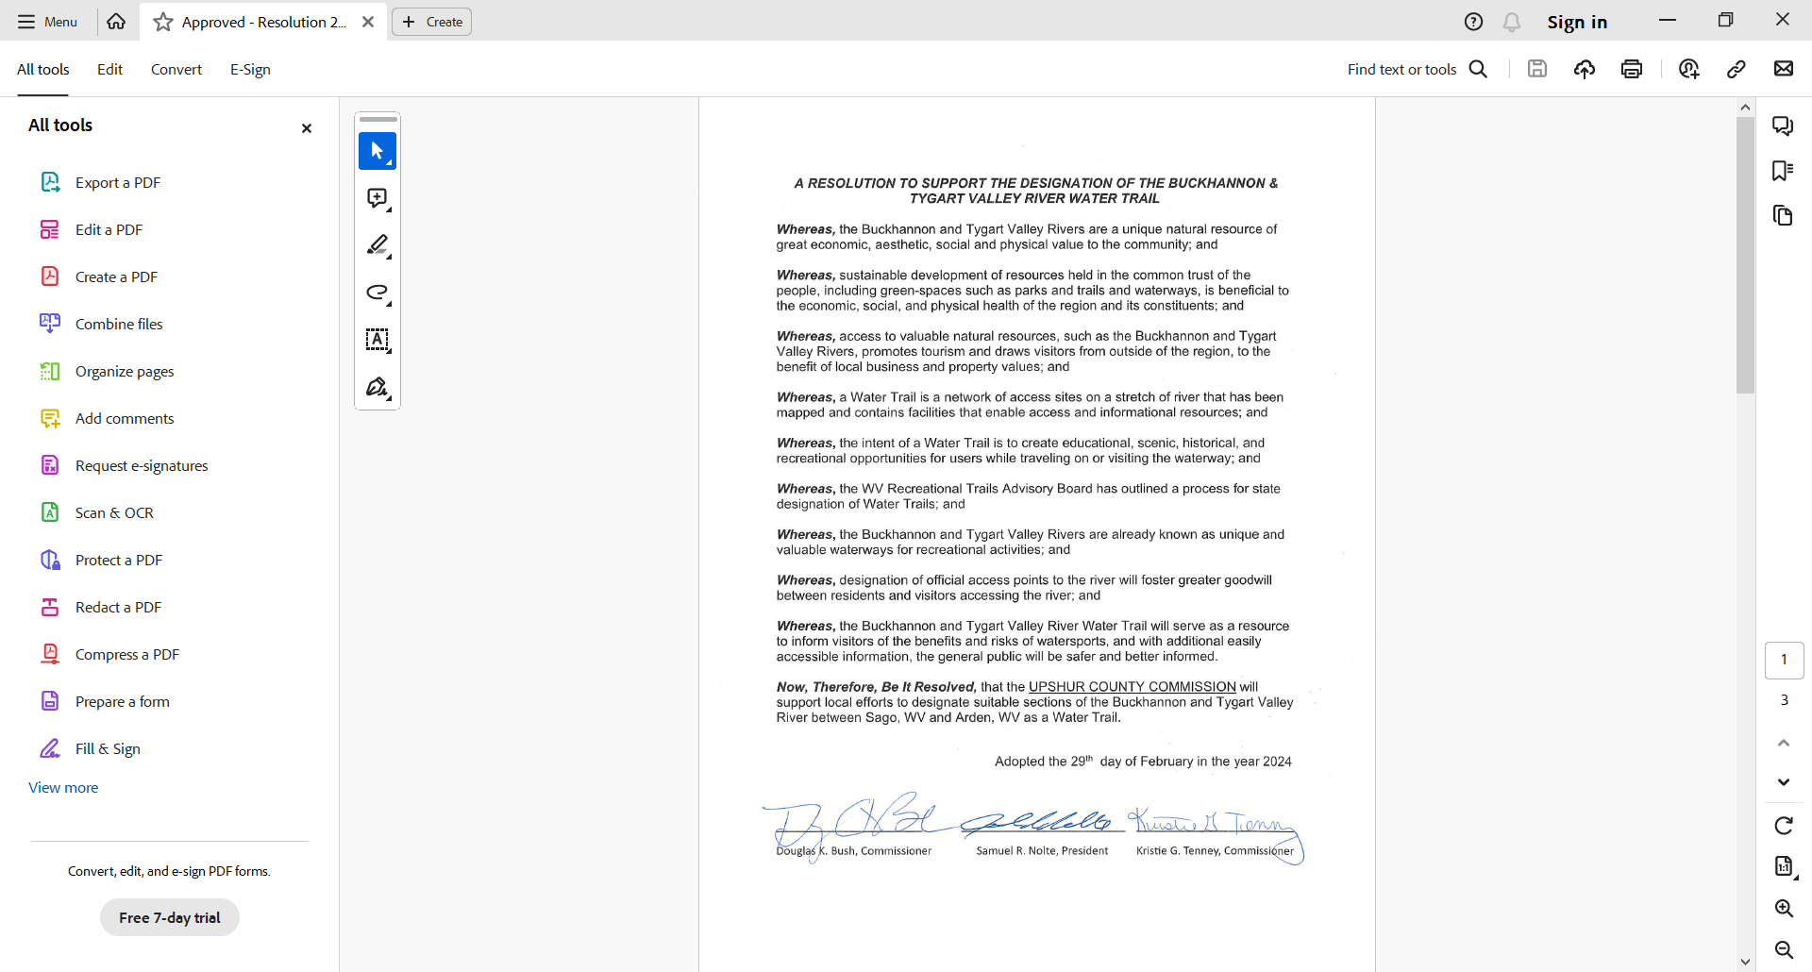

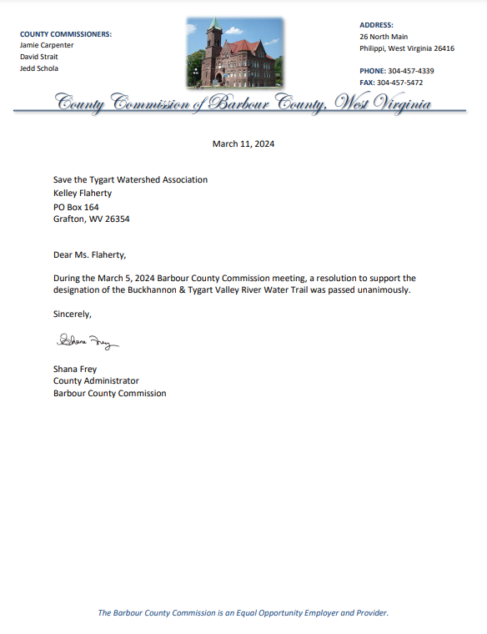

## Appendix D: Water Trail Presentation Slides

We will insert our Water Trail presentation slides from the public meeting here.